Summary of Findings

**DIVERSITY**

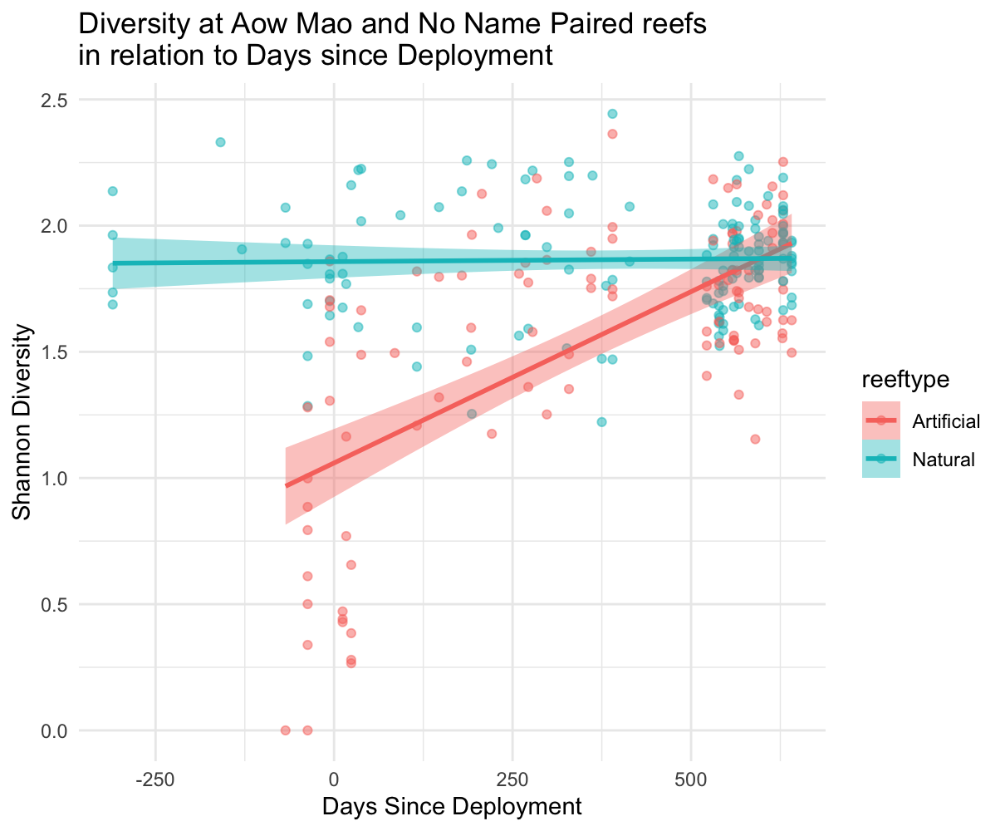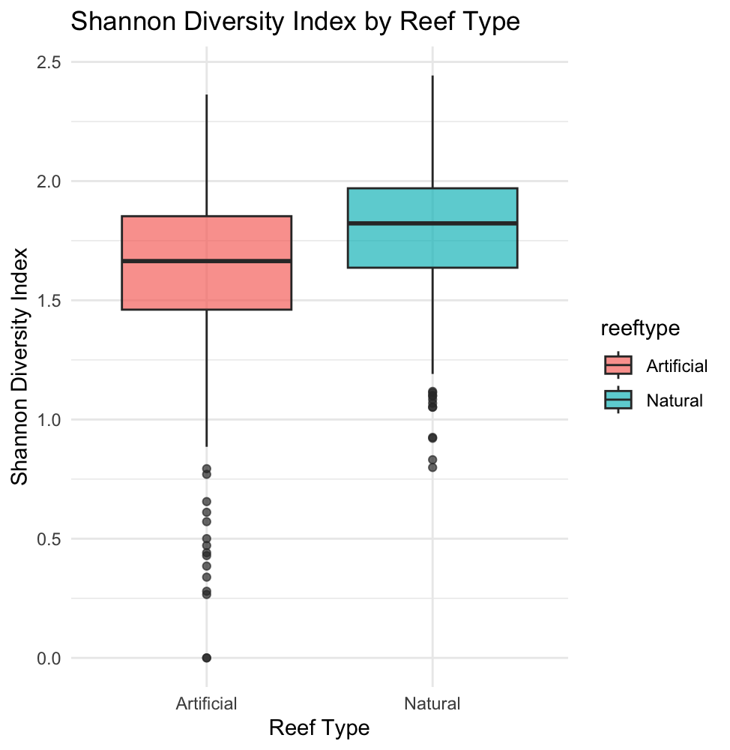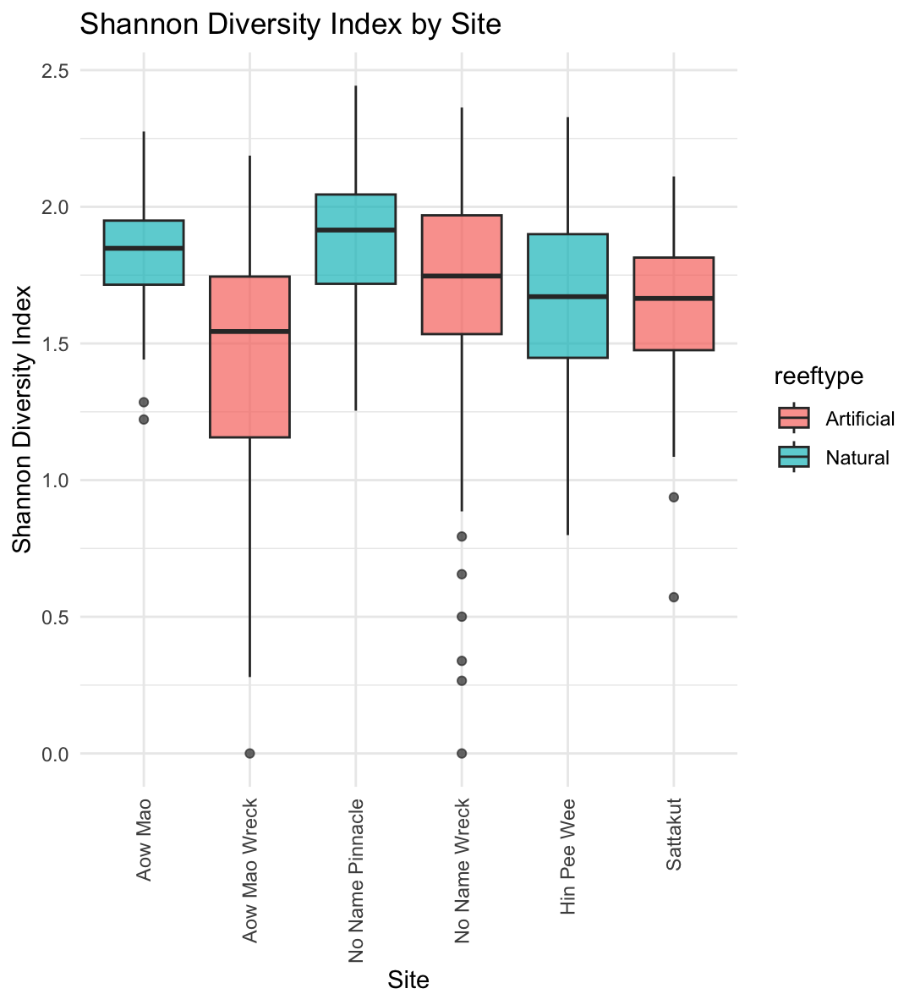

**At the Aow Mao and No Name Pair:**

* A linear mixed-effects model was used to test whether the effect of time since deployment on reef fish diversity differs between artificial and natural reefs. The model included an interaction between reef type and scaled days since deployment, with site included as a random effect.
* There was a significant interaction between reef type and time since deployment (*p* < 0.001), indicating that the trajectory of diversity change over time differs by reef type.
* Diversity increased significantly over time overall (*p* < 0.001).
* The effect of reef type alone was marginally significant (*p* ≈ 0.063), with natural reefs showing slightly higher diversity on average.
* The interaction model significantly improved model fit compared to the additive model (ΔAIC = 59.87; *p* < 0.001).

**At No Name Pair (Pinnacle & Shipwreck):**

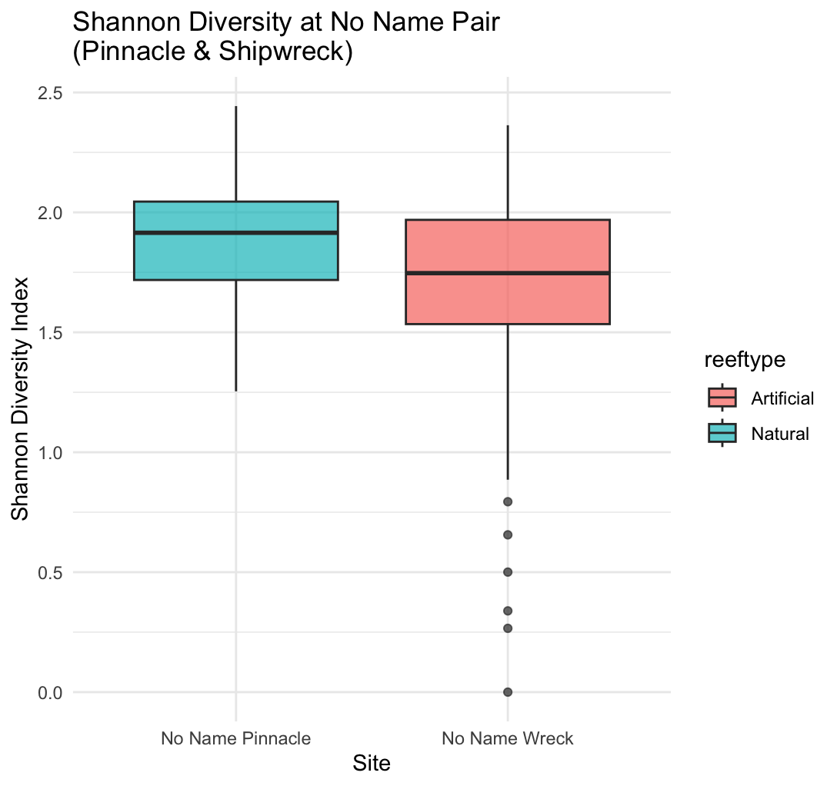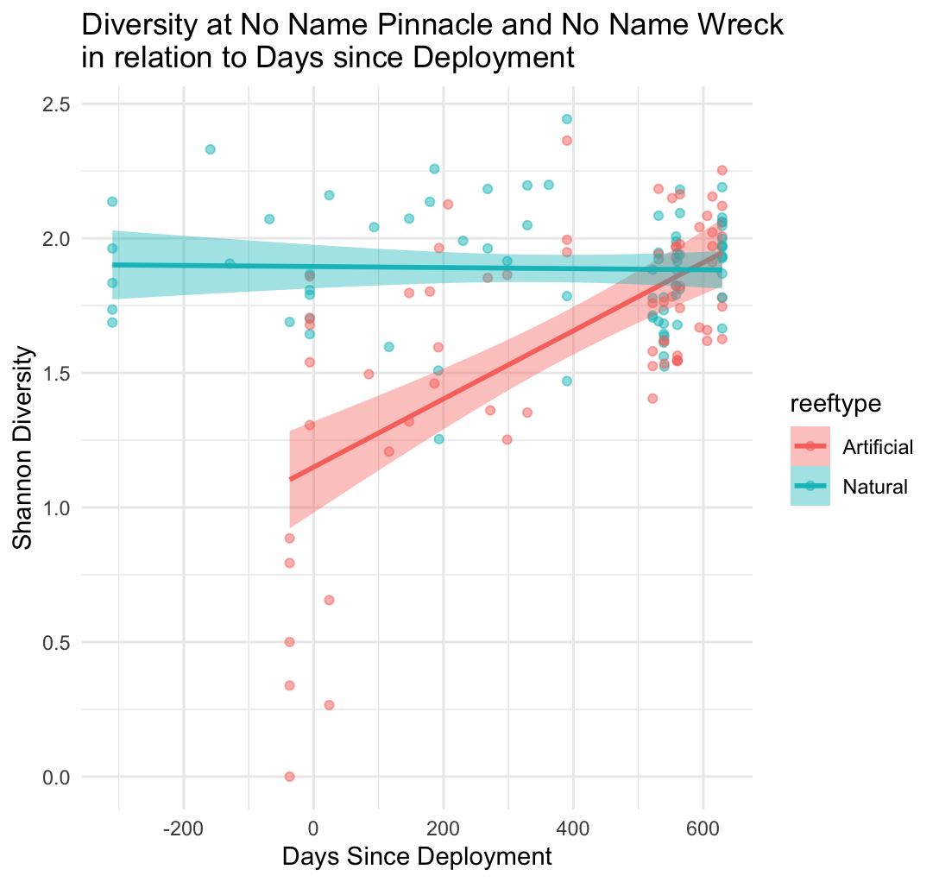

* reeftypeNatural is significantly positive (**p < 0.001**): natural reefs start with higher diversity.
* days_since_scaled is also significantly positive (**p < 0.001**): diversity increases over time for **artificial reefs** (reference group).
* **Interaction term** (reeftypeNatural:days_since_scaled) is **significantly negative** (**p < 0.001**): This means the **rate of increase in diversity over time is slower (or even declining)** on natural reefs compared to artificial reefs.

**At Aow Mao Pair (Fringing Reef & Shipwreck):**

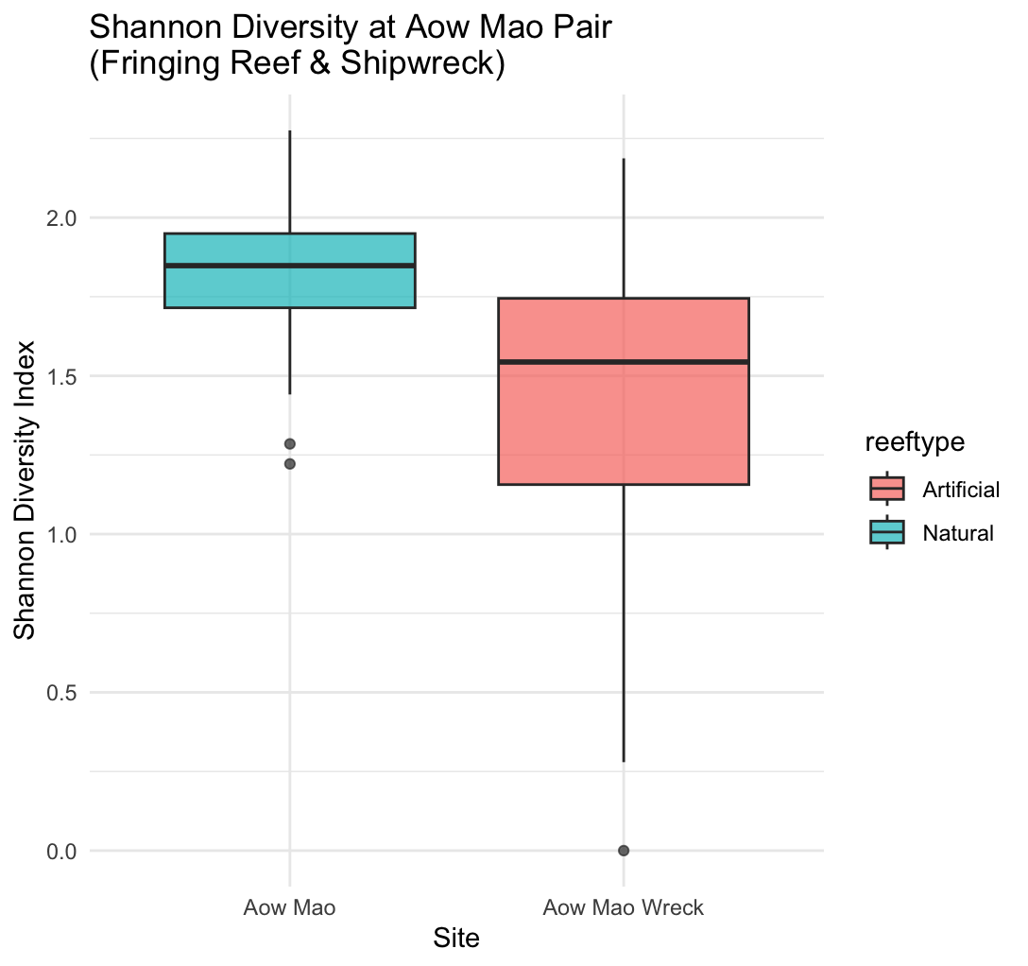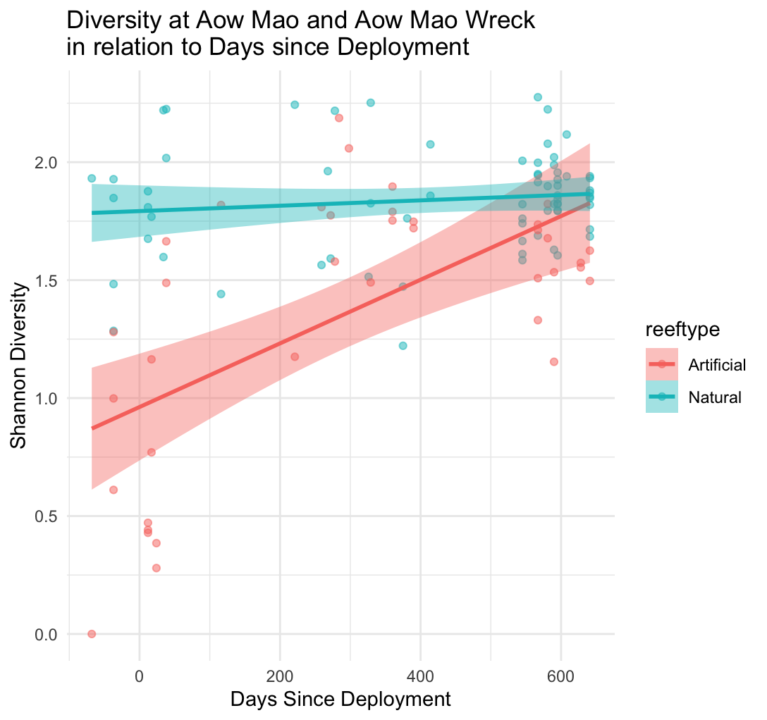

* **Adjusted R² = 0.476** → Your model explains ~48% of the variability in diversity, which is very solid for ecological data.
* **All terms highly significant** (p < 0.001)
* **Artificial reefs** show **faster increases in diversity** over time, possibly due to colonisation processes, while **natural reefs** may already have a mature community with **less change** over the same period.

**At the Sattakut Pair:**

A linear model examining diversity at the two Sattakut sites found:

* **No significant main effect** of reef type (*p* = 0.69).
* **A significant effect of time since deployment** (*p* = 0.02), with diversity decreasing slightly over time.
* Diversity on artificial reefs slightly **declines** over time — **not significant (p= 0.67)**
* Natural reefs may decline slightly faster, **weak evidence** (p = 0.085)

**EVENNESS**

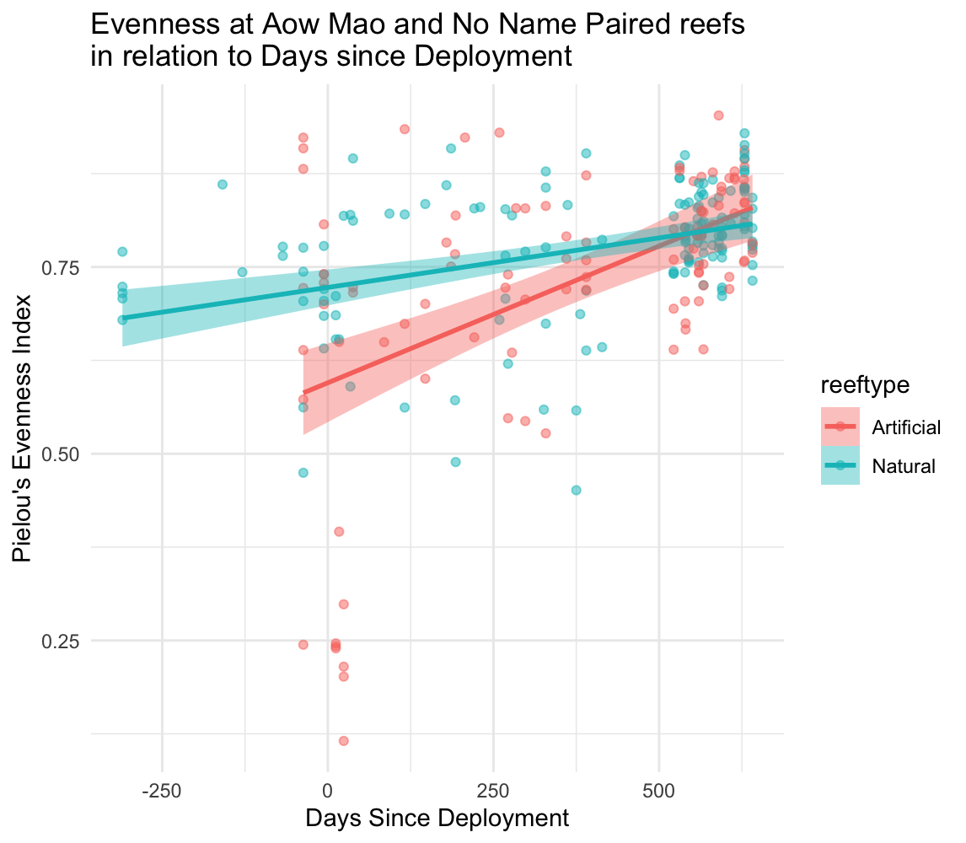

**At the Aow Mao and No Name Pair:**

* days_since_scaled: Positive and highly significant (Estimate ~0.1, p < 0.001), meaning evenness increases over time on artificial reefs.
* Interaction (reeftypeNatural:days_since_scaled): Negative and significant (Estimate ~ -0.061, p = 0.0002), indicating the rate of increase in evenness over time is significantly less on natural reefs compared to artificial reefs.

**At the No Name Pair:**

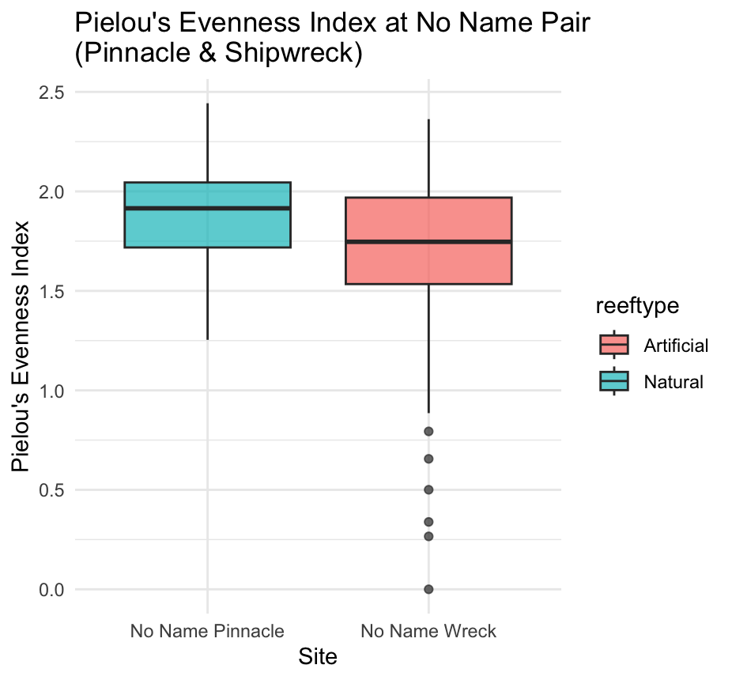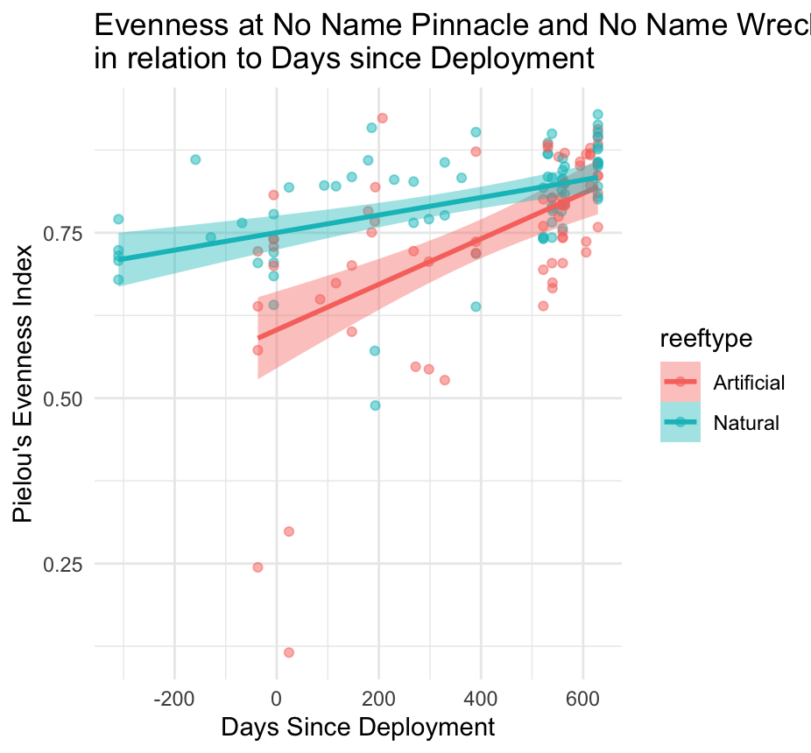

* summary(No_Name_Evenness_model_interact <- lm( evenness ~ reeftype * days_since_scaled, data = pielou_No_Name_Pair ))
* All p values significant and very small

**At the Aow Mao Pair:**

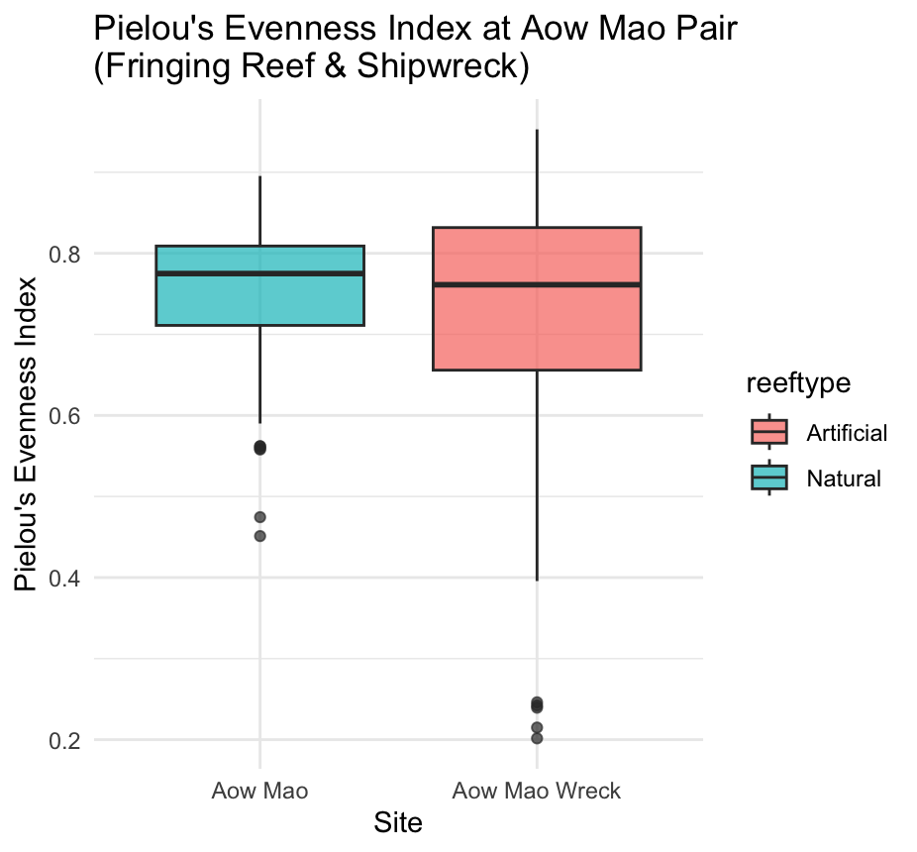

* summary(Aow_Mao_Evenness_model_interact <- lm(evenness ~ reeftype * days_since_scaled ,data = pielou_Aow_Mao_Pair ))
* All p-values significant and very small apart from the interaction which was significant at p = 0.038

**At the Sattakut Pair:**

* reeftype: p = 0.8993 (no difference in evenness by reef type)
* days_since_scaled: p = 0.6796 (no change in evenness over time)
* reeftype:days_since_scaled: p = 0.3442 (no interaction effect)

**FEEDING GUILD**

* Higher-Trophic Level Fish:
  + Main effect: Lower abundance overall compared to grazers (Estimate = -0.715, *p* < 0.001).
  + Interaction with reef type: Not significant (Estimate = 0.06, *p* = 0.70).  
    ➤ Conclusion: There's no significant evidence that higher trophic fish are more abundant at artificial reefs compared to natural ones.
* Invertivores and Mesopredators:
  + Both had significantly lower abundances overall compared to grazers.
  + But their interaction with reef type was significant:
    - Invertivores: More abundant at natural reefs (*p* < 0.001).
    - Mesopredators: Also more abundant at natural reefs (*p* = 0.012).

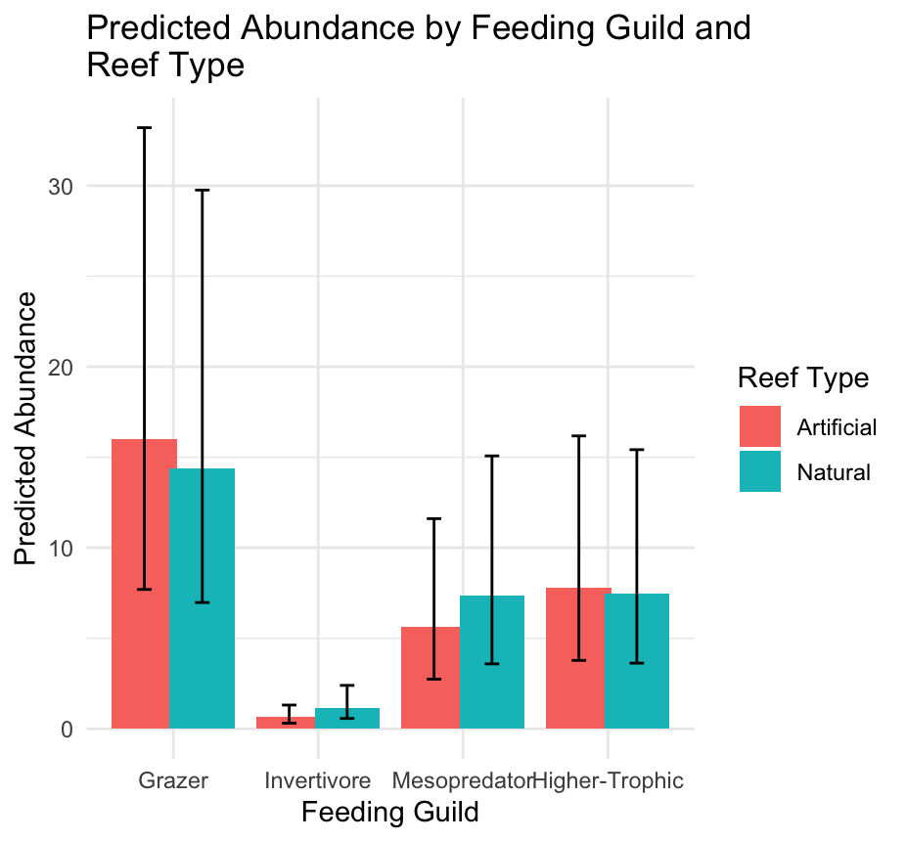

**BRAY-CURTIS DISSIMILARITY**

* adonis2(bray_dist ~ reeftype, data = metadata)
  + **Reeftype explains ~12.7% of the variance** in species composition across your sites (R² = 0.1266).
  + The **F-value = 56.2** shows the strength of that difference.
  + **p = 0.001** indicates this difference is **statistically significant**, i.e., fish communities on artificial and natural reefs are **non-randomly different**.
* nMDS used to visualise community differences.

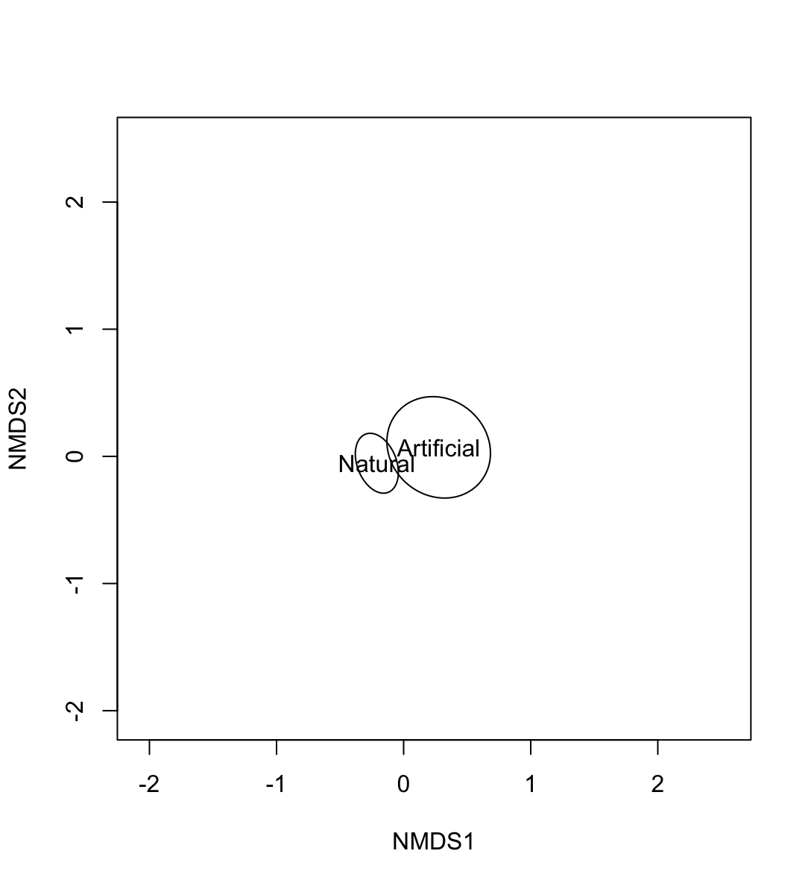

* Dispersion check reveals variances are unequal so interpretation may not be accurate p <0.001.
* ANOSIM which is less sensitive to differences in variance was used to check if result was just due to unequal variance. This revealed a significant difference too. p<0.001.
* Therefore, can continue with SIMPER to see relative contributions of species to Bray-Curtis.
* **Top contributors** to the dissimilarity:
  + russels (more abundant on Artificial reefs)
  + rabbitfish and brownstripe (more on Natural reefs)
  + grouperless30, parrotfish, and snapperover30 — all significant
* **Cumulative contribution**:
  + The top ~5 species (up to grouperless30) already explain ~66% of the dissimilarity.
  + By the time you reach parrotfish, you've explained ~80% — this is typically a cutoff for visualization.

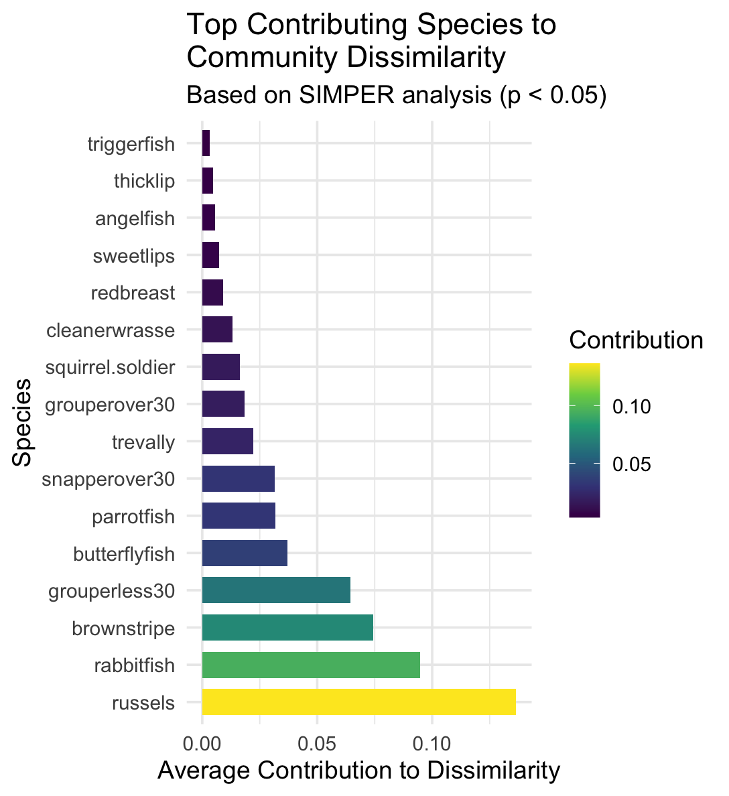

**ABUNDANCE AT THE NATURAL REEFS**

summary(model_over_time_binom <- glmmTMB(

total.N ~ days_since_scaled + (1 | site),

family = nbinom2,

data = new_wrecks_data))

# Strong negative effect of time: counts decline over time since deployment

Species Specific Differences:

* grouperless30, eel, snapperover30, redbreast, cleaner, rabbitfish significantly decreased post deployment
* squirrel.soldier significantly increased ??

Periodic differences (3 month periods)

* The quadratic term (period_3mo.Q), the relationship between abundance and time period is curvilinear.

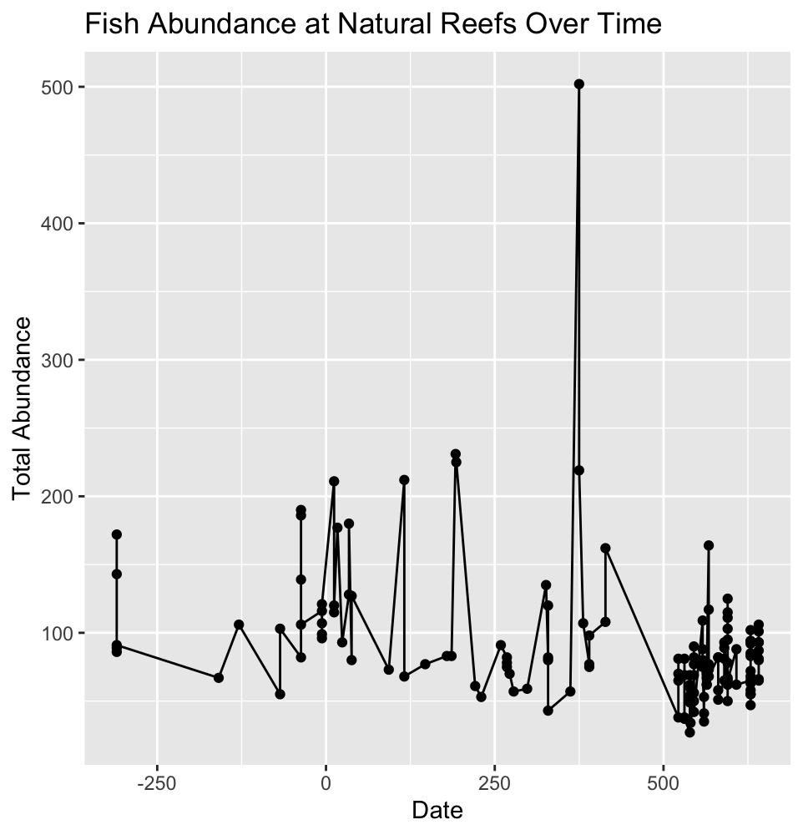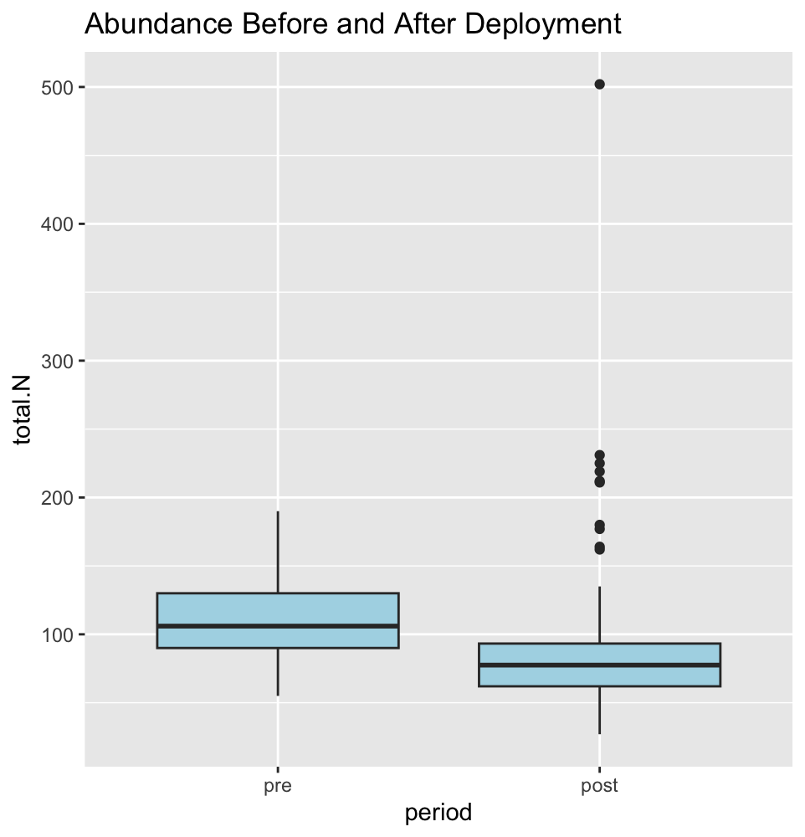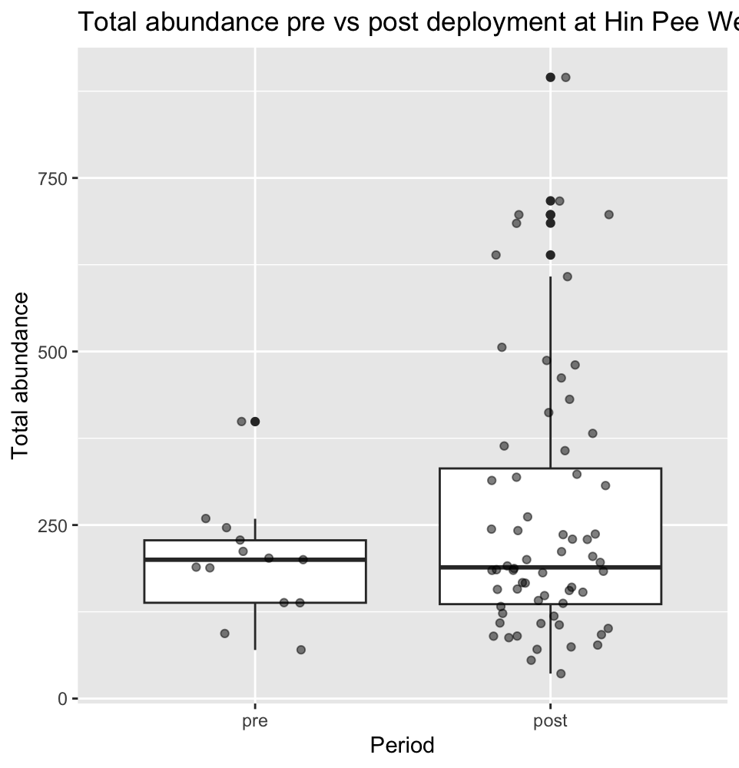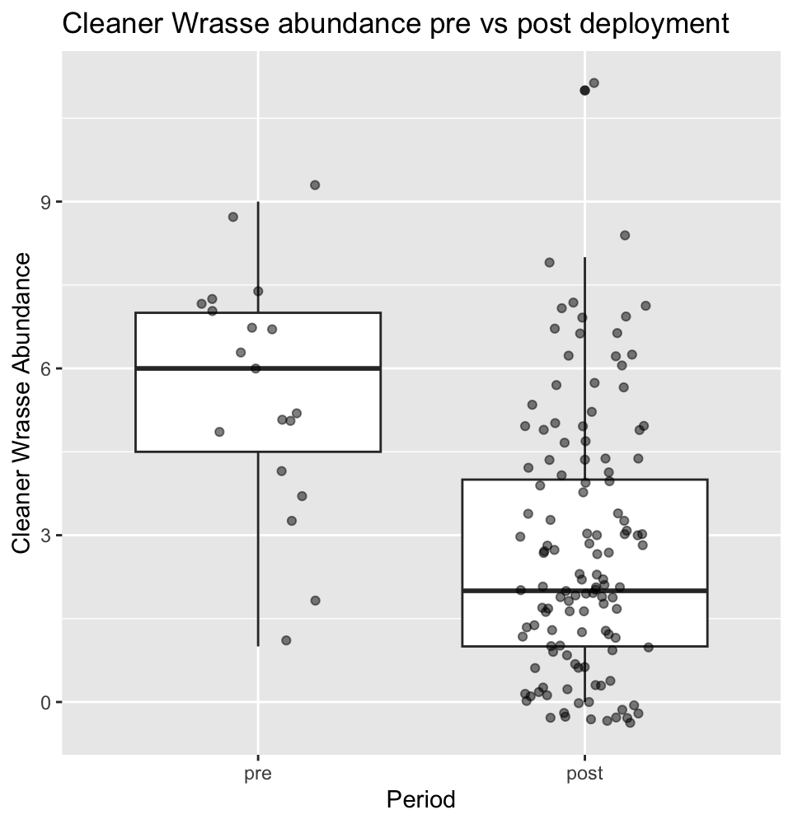

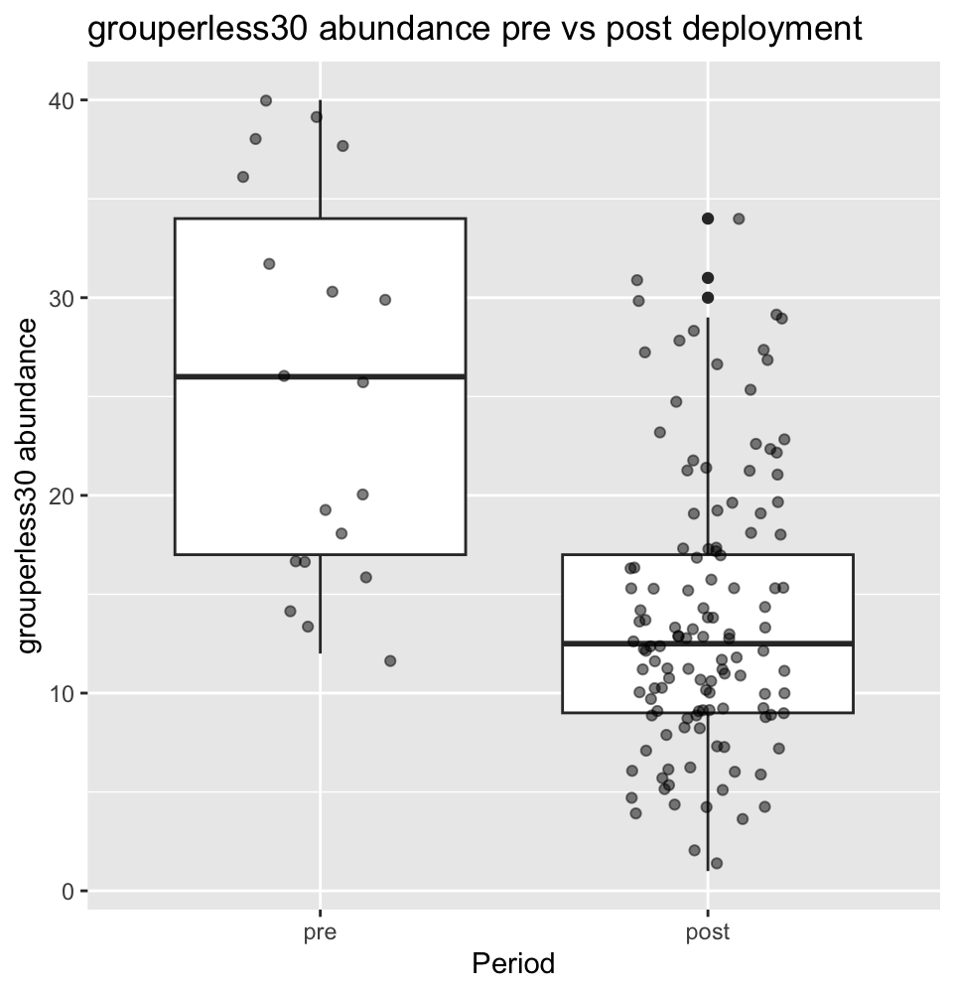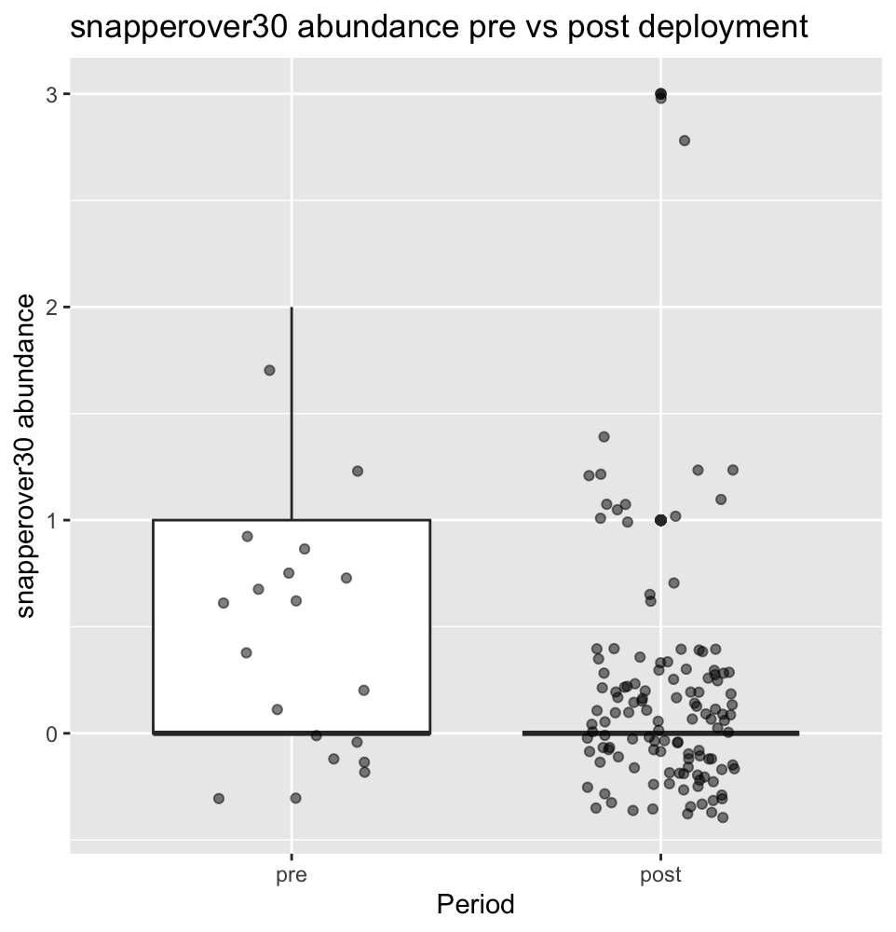

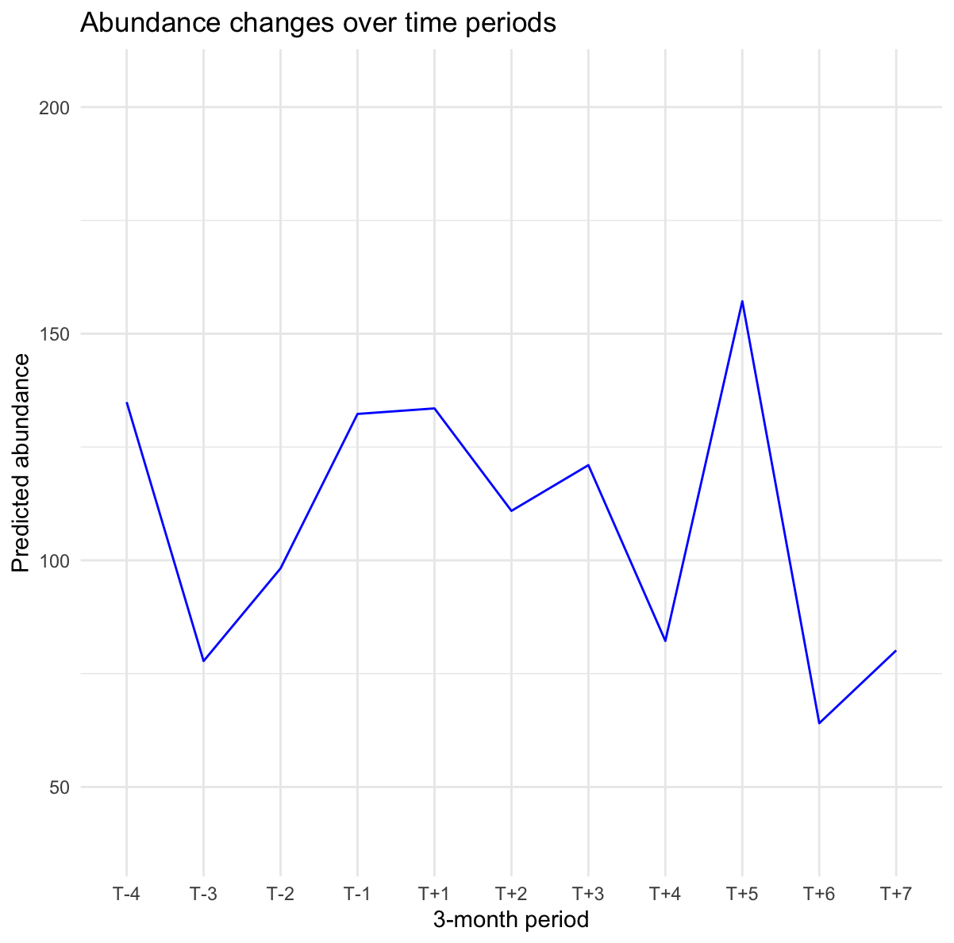

**WRECKS VS NATURAL REEFS**

* No Name Pair
  + Interaction between reeftype and days since deployment was not significant
* Aow Mao Pair
  + The **main effect** of days_since_scaled is positive and significant (Estimate= 0.21595, p= 0.01157), meaning abundance **increases over time** for the reference reef type (likely "Artificial" if factor levels are alphabetical).
  + The **interaction term** (reeftypeNatural:days_since_scaled) is **negative and significant** (Estimate= -0.46103,p= 3.26e-05), meaning the slope for **Natural reefs differs significantly** from Artificial reefs by a decrease of about 0.46.

